SQL Export Step

Objective:

It is used to export data from the selected database. The simplest way of exporting a table data into a file is by using the SELECT...INTO OUTFILE statement that exports a query result directly into a file on the server host

## UI

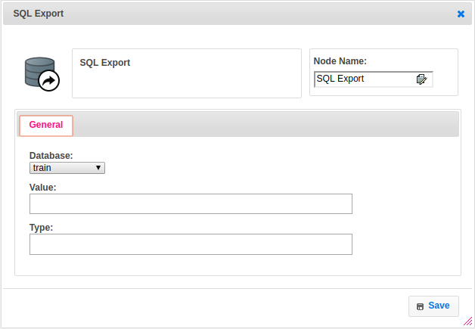

## **Attributes**:

|  |  |
| --- | --- |
| **Attributes** | **Description** |
| Value | A query is a request for data or information from a database table or combination of tables. To exporting a table data into a text file is by using the SELECT...INTO OUTFILE statement that exports a query result directly into a file on the server host |
| Type | To select type as free marker template or handlebar |
| Database | The name of the plugin which we configured earlier with server, username, password and schema |

## Executor Description:

In executor class first it will execute the sql query based on the plugin credentials and get the from respective database then store into result set. Create a file and print the resultset data into that file by using csv printer as per headers in csv format and returns step status as success.

## Dependent plugins:

|  |  |
| --- | --- |
| **Attributes** | **Description** |
| server | The host name "localhost" might resolve to "127.0.0.1" or "::1" on your host, so note this when checking permissions. For example, if a web application's user only has access to "127.0.0.1" on a host, and a defined connection uses "localhost" that resolves to "::1", this connection may lack the proper permissions to the aforementioned web application. User can provide another server url when they want to connect with their host. |
| username | Username to use for the connection. For localhost default is root. |
| password | Optional password for the account used. If you enter no password here, you will be prompted to enter the password when MySQL Workbench attempts to establish the connection. MySQL Workbench can store the password in a vault. |
| schema | When the connection to the server is established, this is the schema that will be used by default. It becomes the default schema for use in other parts of MySQL Workbench |

## Resource:

For more information please refer the below link

<https://dev.mysql.com/doc/>